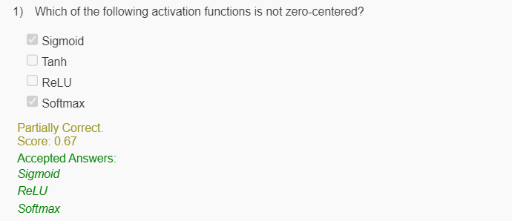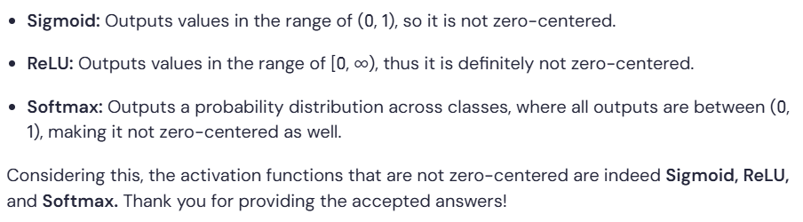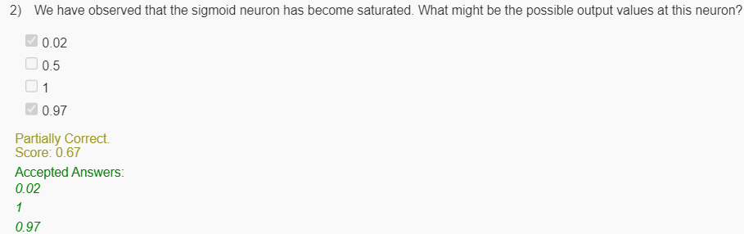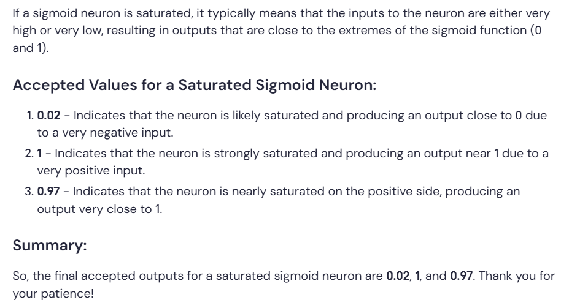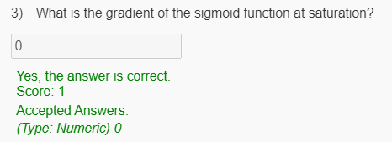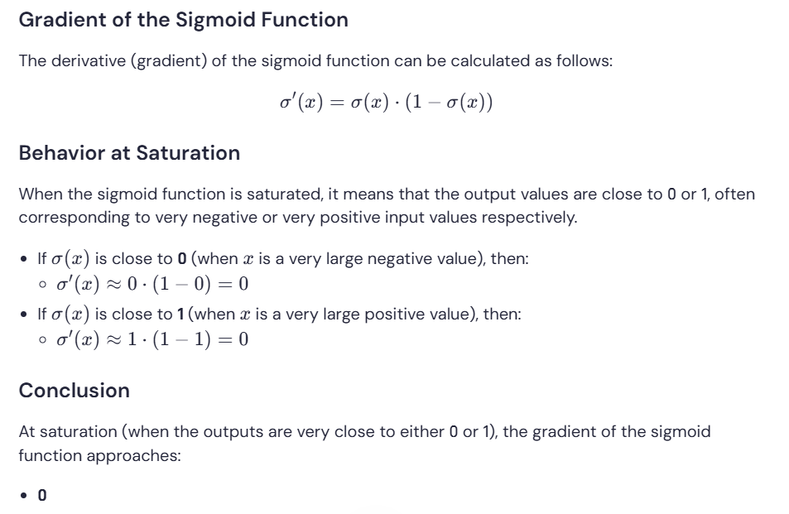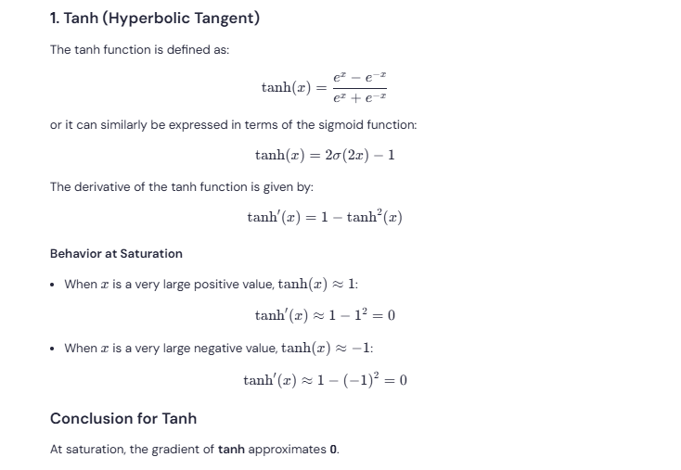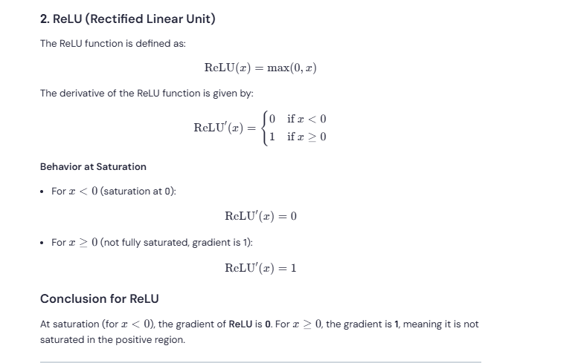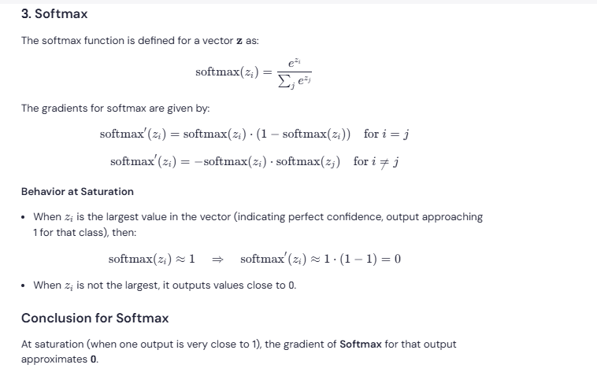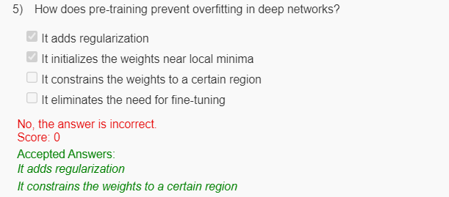

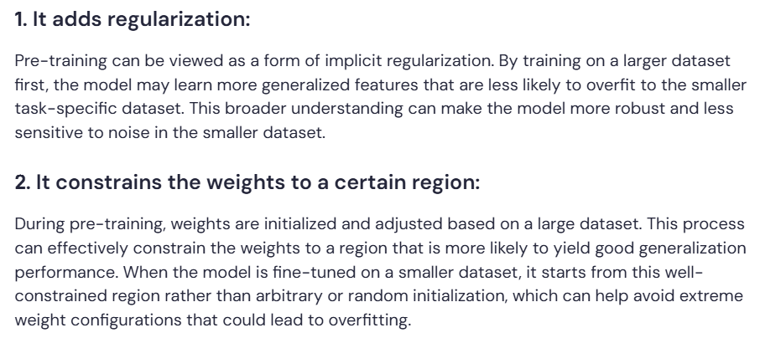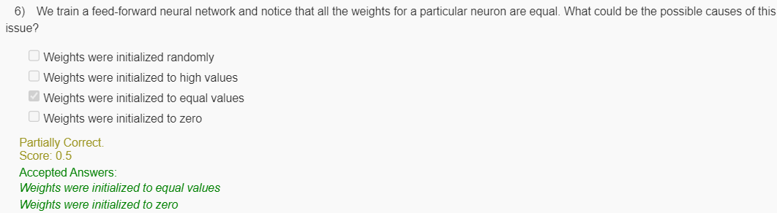

Which of the following methods can help to avoid saturation in deep learning?

 Using a different activation function.

 Increasing the learning rate.

 Increasing the model complexity

 All of the above.

Yes, the answer is correct.  
Score: 1

Accepted Answers:

*Using a different activation function.*

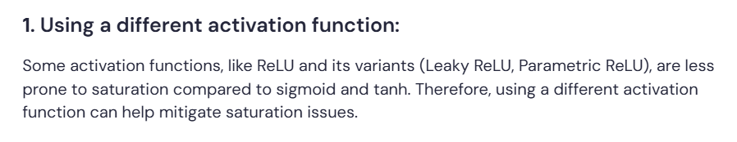

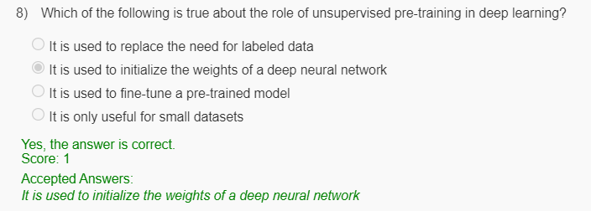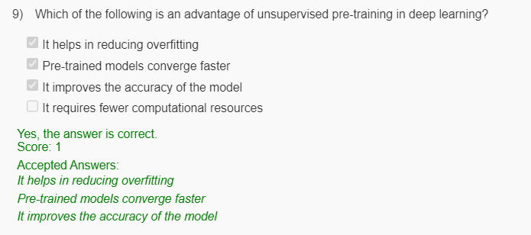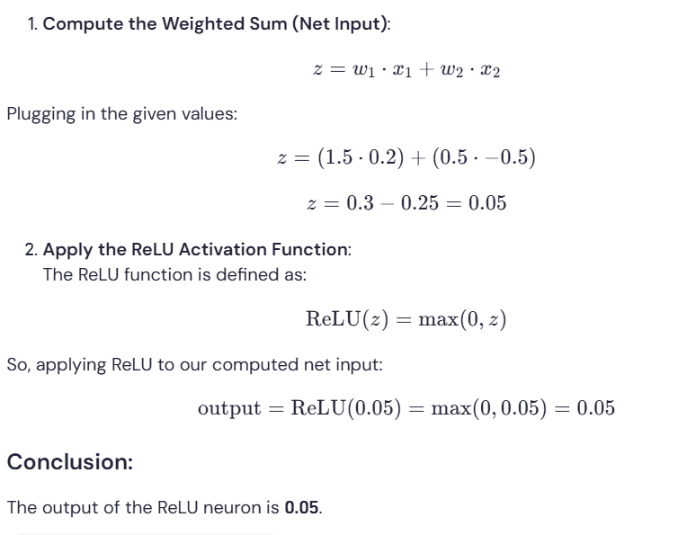

**Question:**

Which of the following best describes the concept of saturation in deep learning?

**Options:**

* When the activation function output approaches either 0 or 1 and the gradient is close to zero.
* When the activation function output is very small and the gradient is close to zero.
* When the activation function output is very large and the gradient is close to zero.
* None of the above.



In Batch Normalization, which parameter is learned during training?

**Options:**

* Mean
* Variance
* γ
* ε

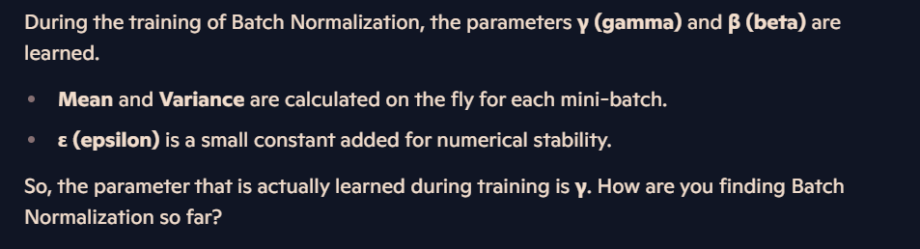

**Question 5:**

What is the main cause of the Dead ReLU problem in deep learning?

* High variance
* **High negative bias**
* Overfitting
* Underfitting

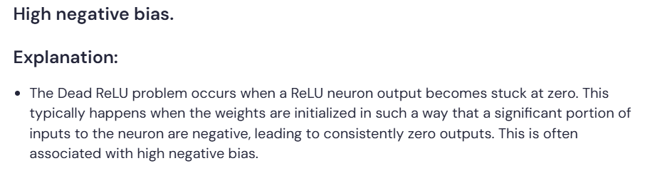

**Question 6:**

How can you tell if your network is suffering from the Dead ReLU problem?

* The loss function is not decreasing during training
* The accuracy of the network is not improving
* **A large number of neurons have zero output**
* The network is overfitting to the training data

